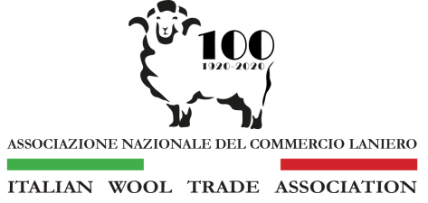

20 July 2023

Mr Mark Waters
President,
Australian Superfine Wool Growers’ Association Inc.
Unit 6/ 42 – 46 Vella Drive,
Sunshine West, Victoria. 3020
Australia

Dear Mr Waters,

As President of the Italian Wool Trade Association, I write this open letter to you regarding matters currently before the Australian Superfine Wool Growers’ Association (ASWGA).

I am aware the ASWGA are engaged in in-house discussions on possible changes to the composition of their membership. We understand that reconciling the varying vested interests with such a discussion can be very sensitive and complex.

The Italian Wool Trade Association, whose members supply 90% of raw material for the Italian textile industry, would like to offer you our collective view on how ASWGA might best reflect the interests of those who buy and use your wool. Quite obviously, the link between us all is that we rely heavily on the viability of an Australian superfine merino industry.

For the past 20 years, the Italian wool trade has been delivering the message to the Australian wool industry that an increasing number of our customers are refusing to use wool from sheep that have been mulesed. On this point, I stress we have never attempted to tell growers how to produce wool, however, we would be negligent in not passing on our customers’ requirements.

The Italian wool trade is now facing the crisis that their customers will cease to accept wool products from mulesed sheep in the very near future. Around the world the list of brands and retailers on this path increases every day.

This market intelligence is passed onto to ASWGA not as an ultimatum but as the stark reality facing both our industries.

There is a critical need for coherent messages from customers of Australian fine wool being delivered to members through a strong ASWGA.

With regard to this current discussion, we feel it very important to note the role of ASWGA as being the information conduit between the Italian wool trade and producers of superfine wool. The Italian wool trade association wants to help facilitate this whenever and wherever possible.

If you wish to contact me over the matters raised in this open letter, I would welcome an email or phone call.

Your faithfully,
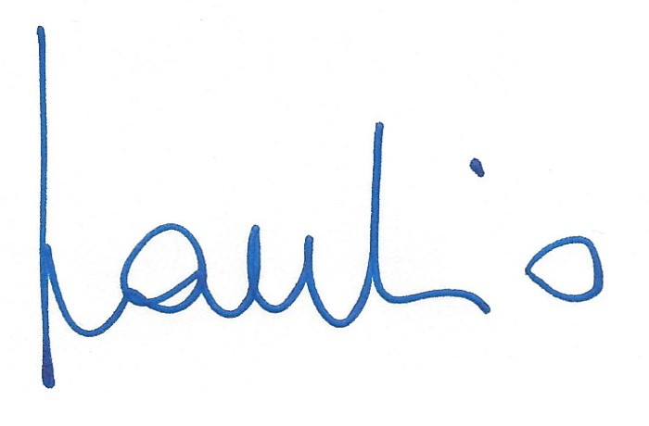
Claudio Lacchio
President

