Sheep enterprises keep getting stronger.
Geoff Casburn Sheep Development Officer NSW DPI

The drought impacts have been very challenging for producers, but strong underlying profitability of sheep enterprises has cushioned the impact. This strength will support longer term investment in the industry and aid in rapid drought recovery (when it rains!).

NSW DPI analysis of standard sheep enterprise gross margins (GM) for 2018 shows the average of all sheep enterprises up by $5.50 to around $50/DSE or $500/Ha at a stocking rate of 10 DSE/ha.
The same analysis with the addition of an 8 month period of full drought feeding shows the majority of sheep enterprises weathering the initial storm (Figure 1).
All Merino based enterprises had a positive GM except for the 20 micron enterprise joined 100% to terminals with -$3/DSE. This enterprise had one of the highest estimated fodder costs at $62/DSE.
Figure 1 NSW sheep enterprise gross margins accounting for an 8 month period of full drought feeding.
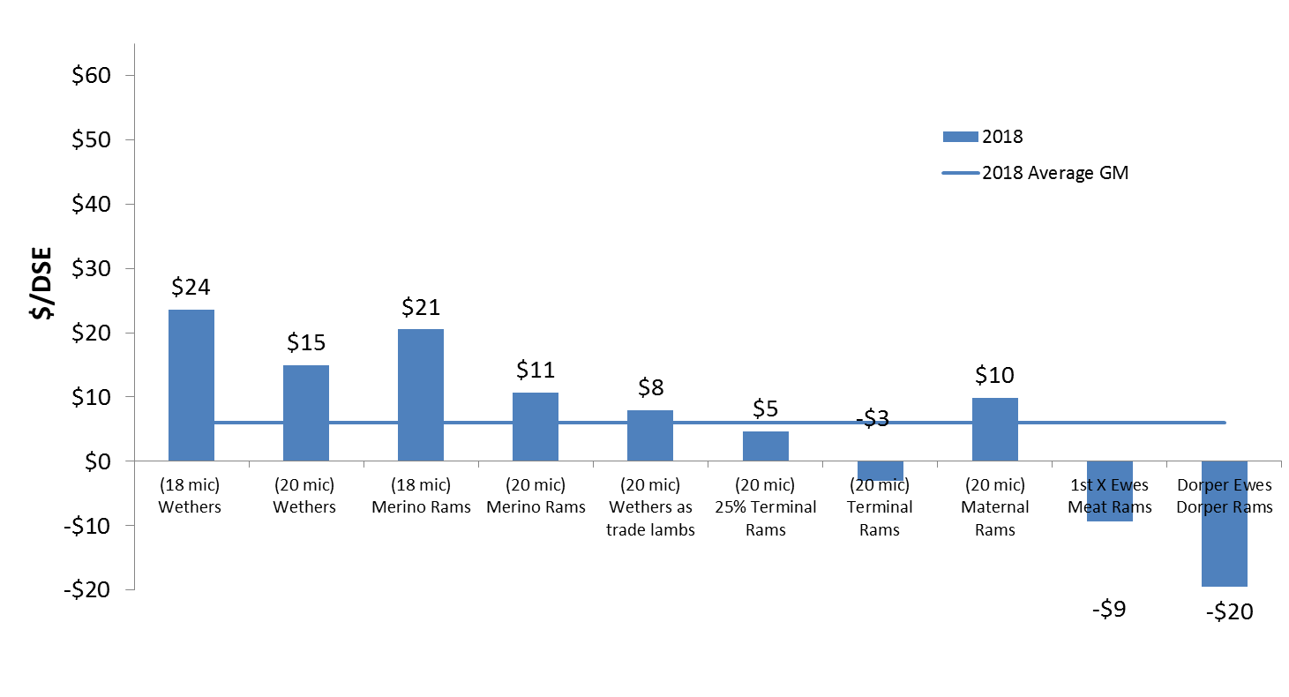
The 18 micron wether enterprise performed the best with a GM of approximately $24/DSE followed by the 18 micron ewe enterprise with $21/DSE and 20 micron wethers with $15/DSE. These three enterprises also had the lowest fodder costs (Figure 2).
The first-cross ewe joined to a meat ram and the self-replacing Dorper enterprise also had negative results of -$9/DSE and -$20/DSE, respectively. While these enterprises had some of the highest feeding costs, they had significantly lower returns per DSE before the additional feeding costs were included. (Figure 3).
It is important to note that assumptions can have large impacts on GMs. As a result, each GM contains a range of sensitivity tables allowing the user to assess the impact of varying assumptions.
For example, in the standard analysis, the first-cross ewe joined to meat rams assumed a weaning rate of 118%. This same enterprise with a weaning rate of 153% returns a GM of $53.15/DSE and breaks-even with the 8 month drought period.
The drought analysis included maintenance feeding of ewes (including during late pregnancy and early lactation), hoggets, wethers and replacements using a total ration price of $400/tonne landed on-farm.
Figure 2 Total drought feeding cost per DSE.
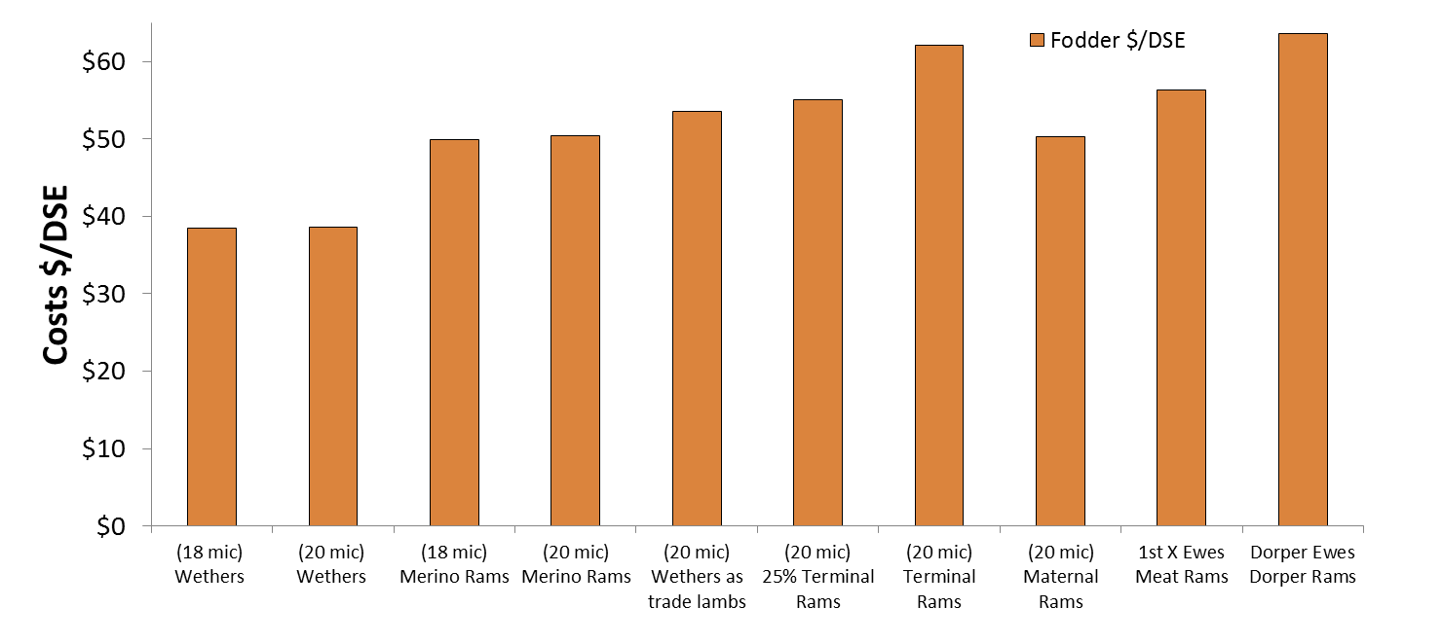
For enterprises selling finished lambs, lambs were fully production fed (total ration price $480/tonne landed) to achieve approximately 20 kg liveweight gain to finish lambs for market. A feed conversion ratio of 6:1 (i.e. 6 kg of feed achieved 1 kg of liveweight gain) was assumed for the meat focussed enterprises and 7:1 for the others.
All production outputs were kept constant (wool cuts, reproduction and growth rates) as it would be difficult to accurately account for changes in production between enterprises, but all production outputs would be expected to be lower in practice, including wool micron.
The drought analysis did not take into consideration overall business performance or any fixed costs or labour.
While drought impacted heavily on sheep enterprises, the prices in 2018 continued to strengthen, providing producers with strong market signals for when conditions improve (Figure 3).
Figure 3. NSW sheep enterprise gross margins for 2018 and 2017 *
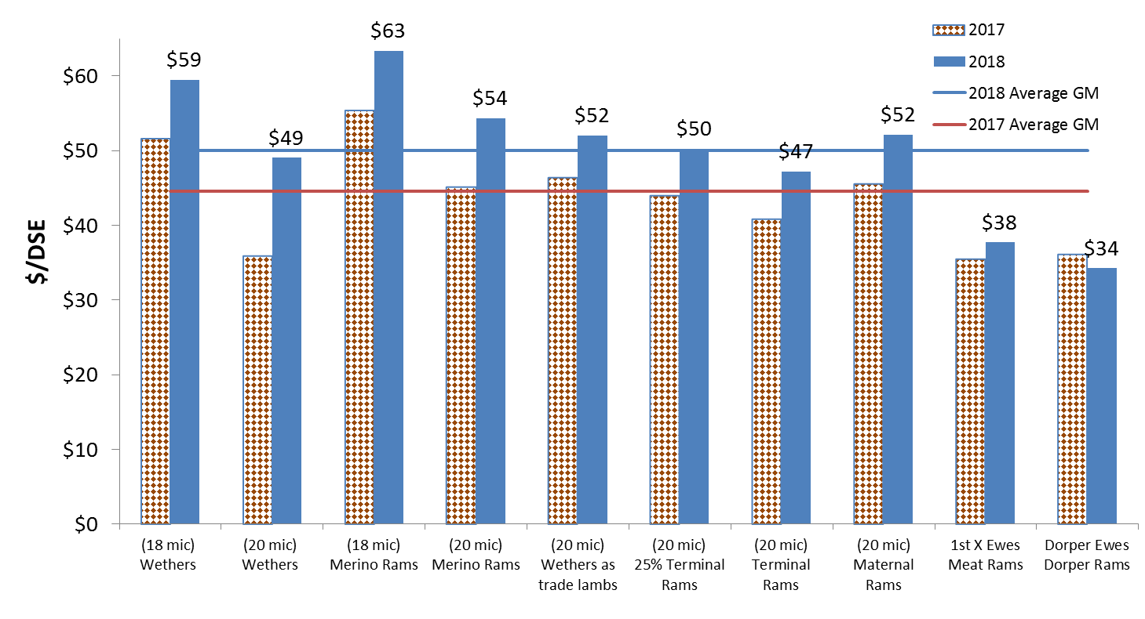
*GM calculations based on average wool and sheep prices from 1 April to 1 September 2017 and 2018

The underlying (i.e. non-drought) standard enterprise gross margins for 2018 are nearly all positive, even while accounting for a supplementary feed price of $320/tonne landed.
The 18 micron self-replacing Merino enterprise achieved the highest GM of $63/DSE, smashing the $600 per hectare barrier at 10 DSE/ha.
While this result is primarily due to increased wool income, the enterprise has also seen a 21% increase in the sale value of four month old wether lambs due to the increased demand from wether enterprises.
Each year production inputs and outputs are kept constant with prices and costs updated with industry figures averaged for the period 1 April to 30 September 2018.
As an example, each year the 18 micron ewe budget includes supplementary feeding for 10 weeks with 3.2 kg of barley fed/head/week (75% of maintenance needs) but in 2018 the grain price was $320 compared with $140 in 2017.
Despite a doubling of grain price, wool focussed enterprises in 2018 were up on average $9.50/DSE, with the 20 micron wether enterprise seeing the largest gain, up $13.07 to $49/DSE, or to put it another way, $130/ha at a stocking rate of 10 DSE/ha.
Even despite having to pay more for wether lamb replacements, wether enterprises performed exceptionally well, with the 18 micron wethers achieving $59/DSE, $7 greater than the next best enterprise with $52/DSE for a 20 micron ewe joined to maternal rams.
The 20 micron wethers also performed well at $49/DSE, $2 more than the 20 micron ewe enterprise joined 100% to terminal rams with $47/DSE and $11 greater than first-cross ewes joined to terminal rams with $38/DSE.
Wool incomes have been steadily increasing with the last three years having seen significant increases (Figure 4). This year, the value of 20 micron wool increased by 37% compared to last year, while to 18 micron wool increased by 17%. The actual price difference between 18 and 20 micron wool value has reduced, with 18 micron worth 15% more than 20 micron compared to 33% in 2017.
Figure 4 Year on year wool income trends 2009 to 2018
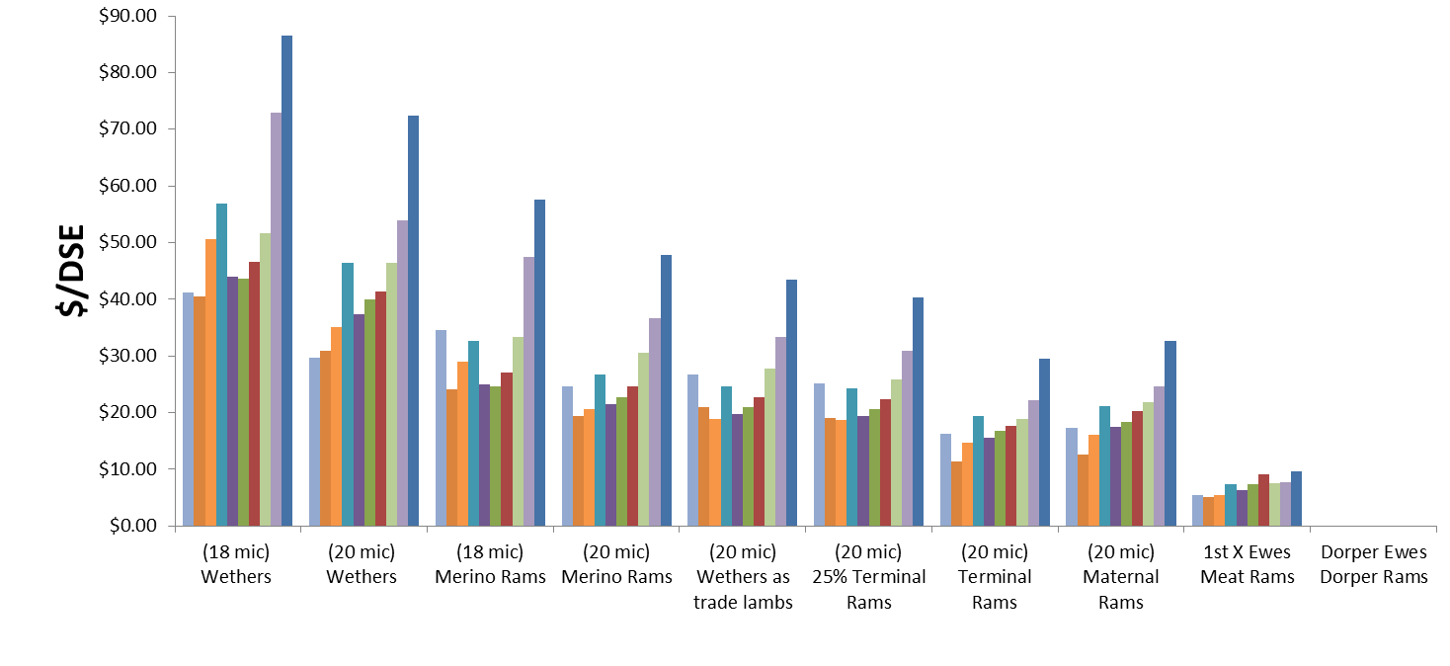
The large income from sheep sales has formed the backbone to sheep enterprises over the last 10 years (Figure 5). This has been driven primarily by the high value of prime lamb and to a lesser extent high mutton values. High meat values provided a stable base supporting increased demand for sheep resulting in increased benefits to those enterprises producing surplus ewes.
Figure 5. Year on year sheep sale income per DSE 2009 to 2018
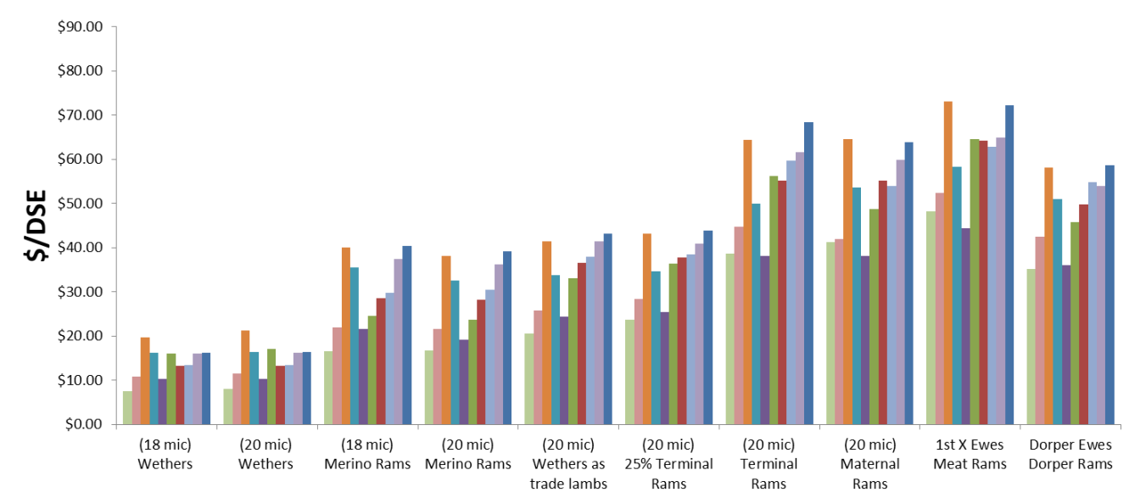
Over the last 10 years, sheep enterprise performance has been steadily improving (Figure 6). Notably, there has been a large improvement in wool focussed enterprises over the last 5 years.
Over the longer term, there is little difference between enterprises (depicted by the dotted line). Should wool and meat prices remain strong, all sheep enterprises are expected to perform well.
Figure 6 Year on Year and 10 year average sheep enterprise Gross Margins 2009 to 2018
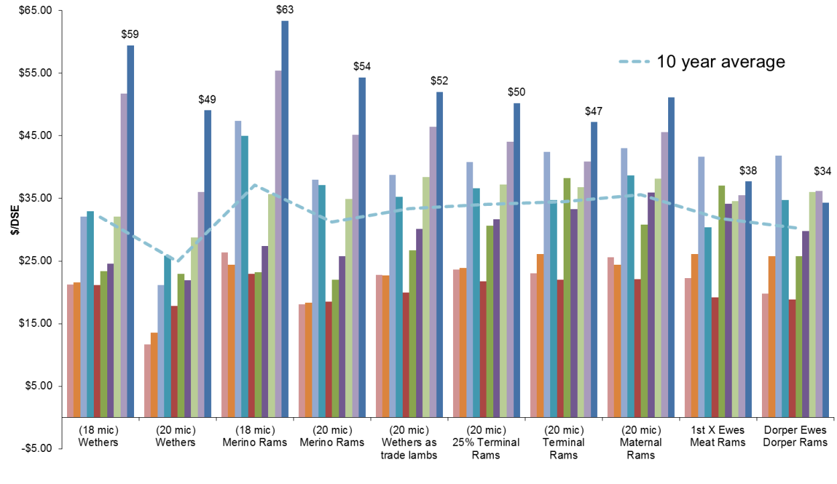
Sheep enterprise costs are also an important consideration. Generally, wool focussed enterprises have greater wool harvesting costs and meat focussed enterprises generally have higher replacement and fodder costs (Figure 7).
As an example, the self-replacing 20 micron ewe enterprise joining 25% of the ewes to terminal rams had the third lowest cost structure with total variable costs of approximately $34/DSE, owing to relatively low replacement costs of $2.81/DSE and fodder costs of $9.45, while the cost of wool harvesting was $8.81/DSE.
In comparison, the 20 micron enterprise joining 100% of ewes to terminal rams had the highest cost structure of approximately $51/DSE as a result of higher replacement costs of $19/DSE and fodder costs of $11.81/DSE.
Wether enterprises had the fourth and fifth highest overall cost structures due to considerably higher wool harvesting costs of around $12/DSE and replacement costs of approximately $14/DSE. However, they had the lowest fodder costs of approximately $4.50/DSE.
Figure 7. Total variable costs broken up into key cost areas.
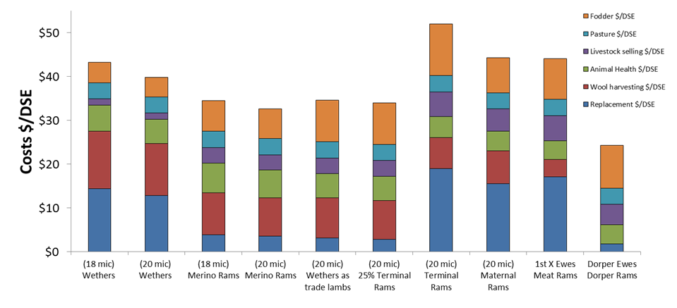
Aside from the drought, it is good news for all sheep producers as underlying enterprise profitability remains strong providing a basis for rapid drought recovery.
Note:
In calculating the 10-year average GMs, there have been slight changes in assumptions. These changes are small and have minimal impact on GM comparisons over time.
GMs only take into account variable costs directly associated with the enterprise and do not take into account capital costs (such as machinery or livestock inventories) or overhead costs such as labour.
Each GM is calculated with and without typical supplementary feeding costs, as well as displaying a range of sensitivity tables. The sensitivity tables allow the user to see the impacts changes to key production, income and cost indicators have on GMs. Readers are urged to develop their own enterprise GMs using their actual costs and income.
To access the full gross margin outputs, visit https://www.dpi.nsw.gov.au/agriculture/budgets/livestock
Sheep and wool prices thanks to MLA market reporting, AuctionsPlus and AWEX.

