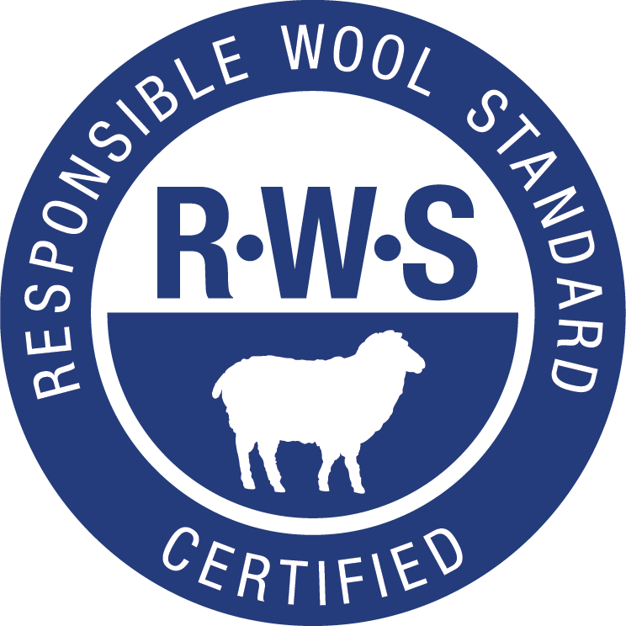

RWS Mulesing Position Paper

Mulesing
Mulesing is the removal of a small area of skin at the back of the sheep, so that wool will no longer grow there. This keeps this area clean of dung and urine stains that attract the blowfly that lays larvae into the stained wool. The larvae will then hatch into maggots that will then feed off the flesh of the sheep internally, leading to suffering and eventually death.

The blowfly is a pest problem throughout Australia, as well as New Zealand and other countries, and is both an animal welfare and a farm management issue. Sheep can get infested very quickly and if not treated can die painfully within days.

Issues
Mulesing has been a hot topic of debate for a long time. Animal rights groups have campaigned against it for years, as it is a painful and stressful procedure. The Australian wool industry has taken steps to address the issues: using pain relief, breeding out the need for Mulesing, and using non-invasive practices, such as crutching (shearing the rear of the animal) and jetting (spraying insecticides on the sheep). Alternative technologies are also being explored. However, Mulesing is still widely practiced in Australia, which is the world’s largest producer of fine wool.

Mulesing and the RWS
In the development of the Responsible Wool Standard, Textile Exchange engaged with a wide variety of stakeholders to get a good understanding of the many options and viewpoints. Our efforts on the Mulesing topic culminated in the Mulesing Panel Discussion that was held as an open webinar (the recording is available at responsiblewool.org). During the discussion, we had representation from animal welfare groups, brands, a pain relief specialist, a merino breeder, a prominent wool trader and processor, a veterinarian, a wool supplier and a wool farmer.

All perspectives were shared, and although there were arguments for allowing Mulesing with pain relief, the overwhelming message from the brands and animal welfare groups was that the RWS would not be an acceptable sourcing option if Mulesing – under any conditions – is allowed. The welfare groups stated that the Australian industry has had 10 years to eliminate Mulesing, and that the industry needs a strong and clear signal that it is not acceptable. The brands stated that they would not use the RWS if it allowed Mulesing, and the standard cannot succeed without the support of brands driving demand.

The RWS is a voluntary standard. Farmers and companies around the world will continue to have the right to choose whether or not to participate.

Responsible Wool Standard

The final RWS requirement pertaining to Mulesing is:

AW4.15 | Mulesing is prohibited. | Farms with ceased mulesing status are accepted. | NC-1

Ceased mulesing: Wool from sheep where the property has ceased mulesing. A mob may contain mulesed sheep; but no lamb born on this property in the last 12 months has been mulesed at the time of certification.

TE position on Mulesing
TE accepts the views of the animal welfare groups and brands, but also understands that Mulesing will not be eliminated overnight, and that there may not be enough immediate supply of non-mulesed wool to meet demand.

Looking forward, TE encourages brands to:
- Source 100% RWS wool when possible.
- Source any non-RWS wool from sheep that are mulesed with pain-relief.
- Work with your supply chain to support the transition to non-mulesing through breeding and adjusted management practices.
- Make long-term commitments, and pay a fair price for your wool.
- Stay engaged with the RWS International Working Group as we continue to look at the development of new alternatives

TE will maintain an open discussion on the mulesing topic and the RWS IWG will look at emerging technologies, such as liquid nitrogen or advanced pre- and post-operative pain relied as they become available for use. We may consider them in the next revision of the standard.

